|  |  |
| --- | --- |
| **Ex. No. 9** | **FORM VALIDATION AND ROUTING USING ANGULAR JS** |
| **Date of Exercise** | **26/10/2022** |
| **Web Host Link** |  |
| **Youtube Link** |  |

**Aim:**

Design User Registration Page as per the following design and perform validation of each fields and generate error message if the field is not correct as per the following constraints a constraints

a. All fields are required, if it is not typed show error near the box

b. Name should not contain numbers otherwise show error

c. Password Must Contain 1 uppercase, 1 lowercase and 1 number and minimum 8 characters otherwise show error

d. Age should be within 18 to 30, otherwise show error

e. Mobile number should be 10 digits, otherwise show error

f. Email should be valid, otherwise show error

g. Gender and state is required

h. Finally enable the submit button if all the above fields are valid.

**Description:**

**Form Validation** in AngularJS is the process of ensuring whether the data entered in a form is correct and complete. When a user submits the form, validation occurs first before the details are sent to the server. The validation process ensures at best possible extent that the details for input fields are entered in the right manner.

In a real-world example, let’s assume a site which requires a registration form to be completed before getting full access to this site. The registration page would have input fields for username, password, email id and so forth.

For example, the email id always needs to be in a format of **username@site.domain**; if someone enters just the username in the email id, then ideally the validation should fail. So validation looks at doing these basic checks before the details are sent to the server for further processing.

**Question 1:**

**Program:**

<!DOCTYPE html>

<html>

    <head>

        <script src="https://code.angularjs.org/1.6.9/angular.js"></script>

        <script>

            var app = angular.module('registration',[])

            app.controller('regcontroller', function($scope)

            {

            });

        </script>

    </head>

    <body ng-app="registration" style="color: blue;">

        <form  ng-controller="regcontroller" name="regform">

            <h1>User Registration Form</h1>

            <table>

                <tr>

                    <td style="width:35%"><label for="name">Name : </label><span style="color: red">*</span></td>

                    <td><input type="text" ng-model="name" id="name" name="name" required pattern="[a-z,A-Z]{1,}">

                    <span style="color: red" ng-show="regform.name.$error.required">Name is required</span>

                    <span style="color: red;" ng-show="regform.name.$error.pattern">Name is invalid</span></td>

                </tr>

                <tr>

                    <td><br></td>

                    <td><br></td>

                </tr>

                <tr>

                    <td><label for="password">Password :</label><span style="color: red">*</span></td>

                    <td><input type="password" ng-model="Password" id="password" name="password" required pattern="(?=.*\d)(?=.*[a-z])(?=.*[A-Z]).{8,}">

                        <span style="color: red" ng-show="regform.password.$error.required">password is required</span>

                        <span style="color: red;" ng-show="regform.password.$error.pattern">Password is invalid</span></td>

                </tr>

                <tr>

                    <td><br></td>

                    <td><br></td>

                </tr>

                <tr>

                    <td><label for="age">Age : </label><span style="color: red">*</span></td>

                    <td><input type="number" ng-model="age" id="age" name="age" required min="18" max="30">

                        <span style="color: red" ng-show="regform.age.$error.required">Age is required</span>

                        <span style="color: red;" ng-show="regform.age.$error.min">Age is invalid</span>

                        <span style="color: red;" ng-show="regform.age.$error.max">Age is invalid</span></td>

                </tr>

                <tr>

                    <td><br></td>

                    <td><br></td>

                </tr>

                <tr>

                    <td><label for="number">Mobile Number : </label><span style="color: red">*</span></td>

                    <td><input type="number" ng-model="number" id="number" name="number" required pattern="[0-9]{10}">

                        <span style="color: red" ng-show="regform.number.$error.required">Number is required</span>

                        <span style="color: red;" ng-show="regform.number.$error.pattern">Mobile number is invalid</span></td>

                </tr>

                <tr>

                    <td><br></td>

                    <td><br></td>

                </tr>

                <tr>

                    <td><label for="email">Email : </label><span style="color: red">*</span></td>

                    <td><input type="email" ng-model="email" id="email" name="email" required>

                        <span style="color: red" ng-show="regform.email.$error.required">Email is required</span>

                        <span style="color: red" ng-show="regform.email.$error.email">Email Format</span></td>

                </tr>

                <tr>

                    <td><br></td>

                    <td><br></td>

                </tr>

                <tr>

                    <td><label for="gender">Gender :</label><span style="color: red">*</span></td>

                    <td><input type="radio" ng-model = 'gender' name="gender" value="male" id="gender" required>Male

                        <input type="radio" ng-model = 'gender' name="gender" value="female" id="gender" required>Female

                        <span style="color: red" ng-show="regform.gender.$error.required">Gender is required</span></td>

                </tr>

                <tr>

                    <td><br></td>

                    <td><br></td>

                </tr>

                <tr>

                    <td><label for="state">State :</label><span style="color: red">*</span></td>

                    <td><select ng-model="state" id="state" name="state" required>

                        <option>TamilNadu</option>

                        <option>Kerala</option>

                        <option>AndhraPradesh</option>

                        <option>Karnataka</option>

                        <span style="color: red" ng-show="regform.state.$error.required">State is required</span></td>

                </tr>

                <tr>

                    <td><br></td>

                    <td><br></td>

                </tr>

                <tr>

                    <td></td>

                    <td><input type="submit" ng-disabled=" regform.name.$error.required || regform.password.$error.required || regform.age.$error.required ||

                         regform.number.$error.required || regform.email.$error.required || regform.gender.$error.required || regform.state.$error.required" ></td>

                </tr>

            </table>

        </form>

    </body>

</html>

**Output**

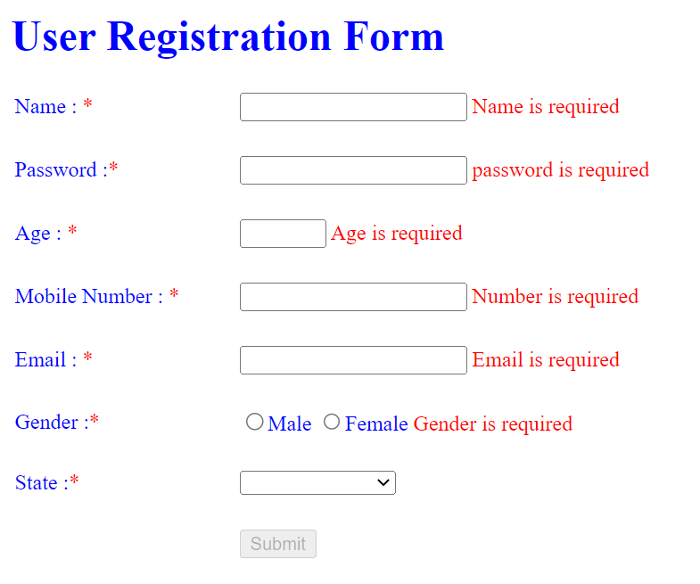

**Question 2:**

**Program:**

<!DOCTYPE html>

<html lang="en">

<head>

    <meta charset="UTF-8">

    <meta http-equiv="X-UA-Compatible" content="IE=edge">

    <meta name="viewport" content="width=device-width,initial-scale=1.0">

    <title>Document</title>

    <script src="https://ajax.googleapis.com/ajax/libs/angularjs/1.6.9/angular.min.js" type="text/javascript"></script>

    <script src="https://ajax.googleapis.com/ajax/libs/angularjs/1.6.9/angular-route.js"></script>

    <script>

        var app = angular.module('myapp', ['ngRoute']);

        app.config(function ($routeProvider) {

            $routeProvider.when('/home', {

                templateUrl: 'color.html'

            })

                .when('/reg', {

                    templateUrl:'registration.html'

                })

                .when('/currency',{

                    templateUrl:'currency.html'

                })

                .when('/bmi',{

                    templateUrl:'bmi.html'

                })

                .when('/car',{

                    templateUrl:'electric_cars.html'

                })

                .otherwise({redirectTo:'/'})

        })

    </script>

</head>

<body ng-app="myapp">

    <table cellspacing = 30 border = "0" width = "100%" style="background-color: gray; color: aqua;">

    <td><a href="register.html">RegistrationForm</a></td>

    <td><a href="currency.html">CurrencyConverter</a></td>

    <td><a href="bmi.html">BMI</a></td>

    <td><a href="Electric_cars.html">ElectricCar</a></td>

    </table>

    <hr>

    <div ng-view>

    </div>

</body>

</html>

**Output**

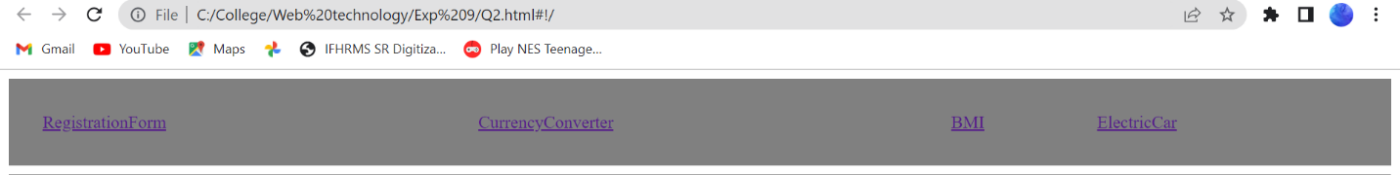

**Result:**

Thus the above program is executed and verified successfully.